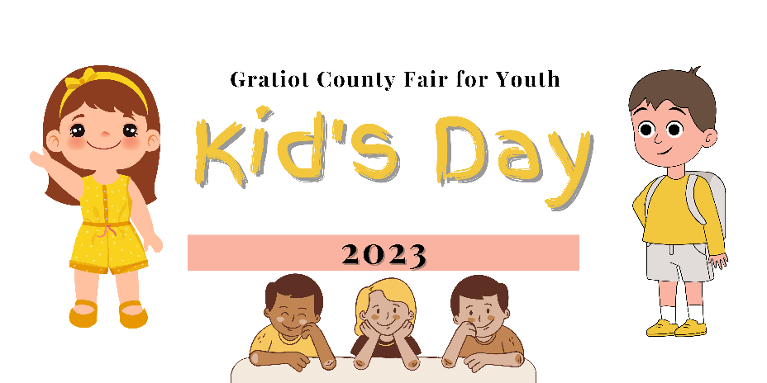

Kid’s Day Exploration Tent Booth Registration Form:
Group/Organization Name: ___________________________________________
Contact Person: _____________________________________________________
Address: ___________________________________________________________
City: ____________________ Zip Code: ____________________________
Email Address: ______________________________________________________
Telephone Number: __________________________________________________
Day of the Event Telephone Number: ____________________________________
My Organization would like to request a (circle or highlight one)
Tent Space (includes 6’ table & 2 chairs- no electricity)
Outdoor Space-Please describe what you need
Bringing Vehicle or Trailor
What question would you like the kids to answer while at your booth? What educational activity will you be sharing/teaching.

Brief description of items to be displayed, handed out, acted out or set up (please do not sell any items):

Please describe any needs you have:

In using this space for the 2022 Kid’s Day Exploration Tent, I amfully aware that the MSU Extension, Gratiot County Fair for Youth, and/or Gratiot County assumes no responsibility.
Signature of contact person: ______________________________ Date: ________
Return this agreement to
Gratiot County Fair For Youth,
701 S. Lincoln Ave., Alma MI, 48801
Telephone: 989-466-5071 Email: interngcffy@gmail.com

